

**LOVELY PROFESSIONAL UNIVERSITY, JALANDHAR**

CSE326 – INTERNET PROGRAMMING LABORATORY

PROJECT REPORT

Topic:

“Sport website”

Submitted by:

Prasath Vedharethinam (12211631)

Roll Number:58

Section: K22PK

Submitted to:

Mr. Mir Junaid Rasool

**TABLE OF CONTENTS**

1. **Introduction**
   1. **Objective of the project**
   2. **Description of the project**
   3. **Scope of the project**
2. **System Description**
3. **Design**
4. **Screenshots**
5. **Future work**

1.Introduction

* 1. Objective of the project

The Objective of the project “sport club “is to make a website which provides and manages various club activities

The website should show how an average sport club’s website looks like and the contents of sport club website the minimum amount of information required in order for the customer to join a sports club and acquire the basic information in order to make their choice whether to join or choose an appropriate subscription according to their liking, to look up the availability and versatility of the sports and contact as well as clear queries from the club.

b. Description of the project

The “sport club” website is a website developed to show how websites related to sport clubs are created using HTML, CSS, JavaScript.

The various element present in this website are:

Home page:

* It contains hyperlinks to the sub pages
* the logo of the club
* the name of the club
* a small introduction of the club

About us:

* the about us page contains the major information as well as the past achievements of the club

Our club:

* shows the clubs available as well as their names with images

Subscription:

* The subscription page shows the available subscription as well as the pricing of the subscription

Contact us:

* The contact us page shows the links to where you can contact the host of a website

c. Scope of the project

To make a website using HTML, CSS, JavaScript that is:

* Easy to access and navigate through
* Provides and manages various club activities
* Display images and information about clubs available
* Contain the logo and the name of the club
* Allows to choose an appropriate subscription
* Allows to contact as well as clear queries from the club

2.System Description

Program Used:

* HTML
* CSS

Software used:

Visual Studio Code Version 1.73

Windows 64 bit

Software which can be used to view:

* Google (any version)
* Mozilla Firefox (any version)
* Firefox (any version)
* Microsoft Edge (any version)

3.Design

Home Page

Home

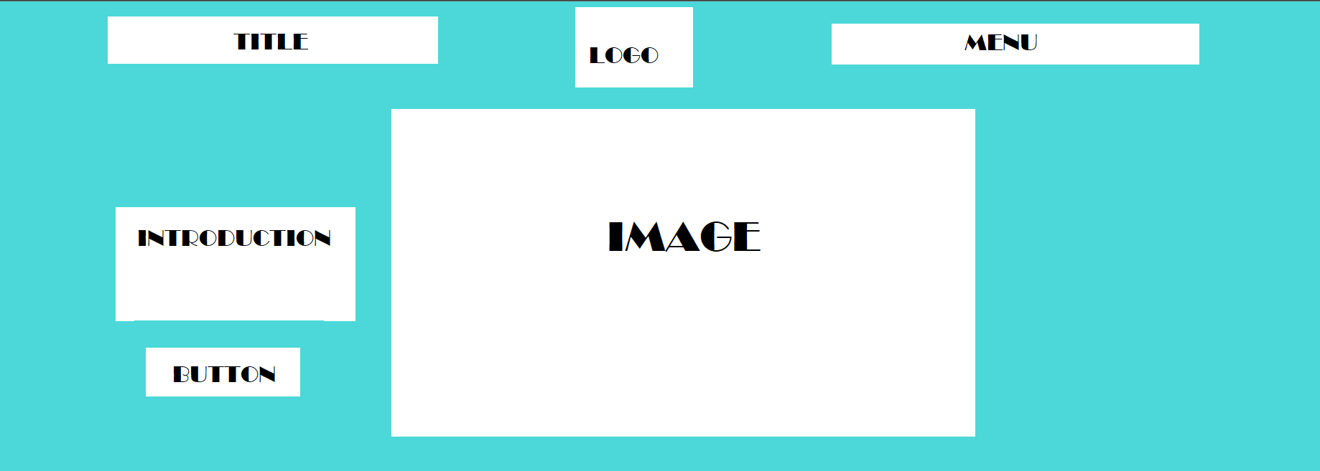

About Us

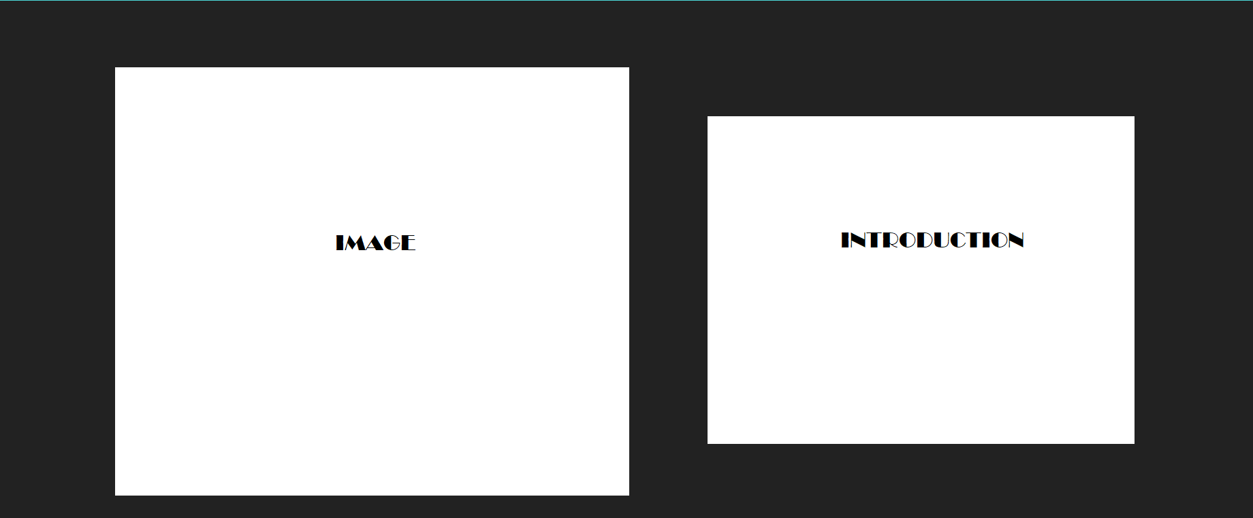

Our clubs

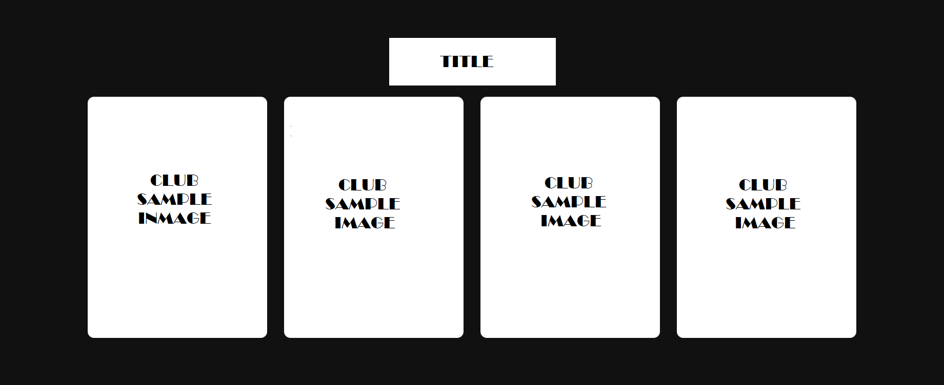

Subscriptions

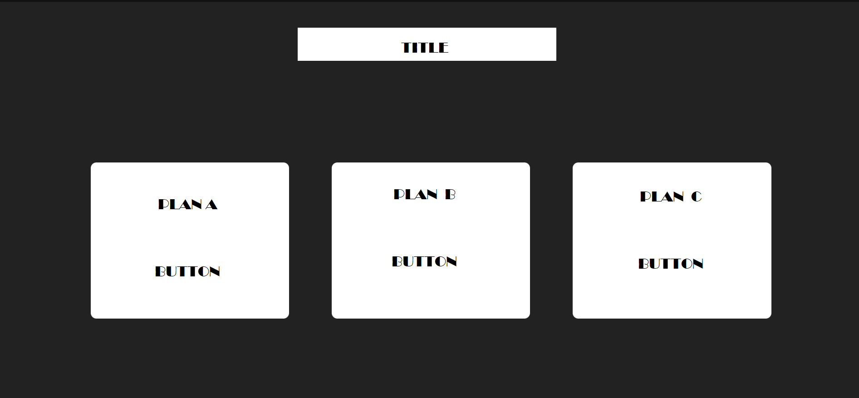

Contact us



Subscription page

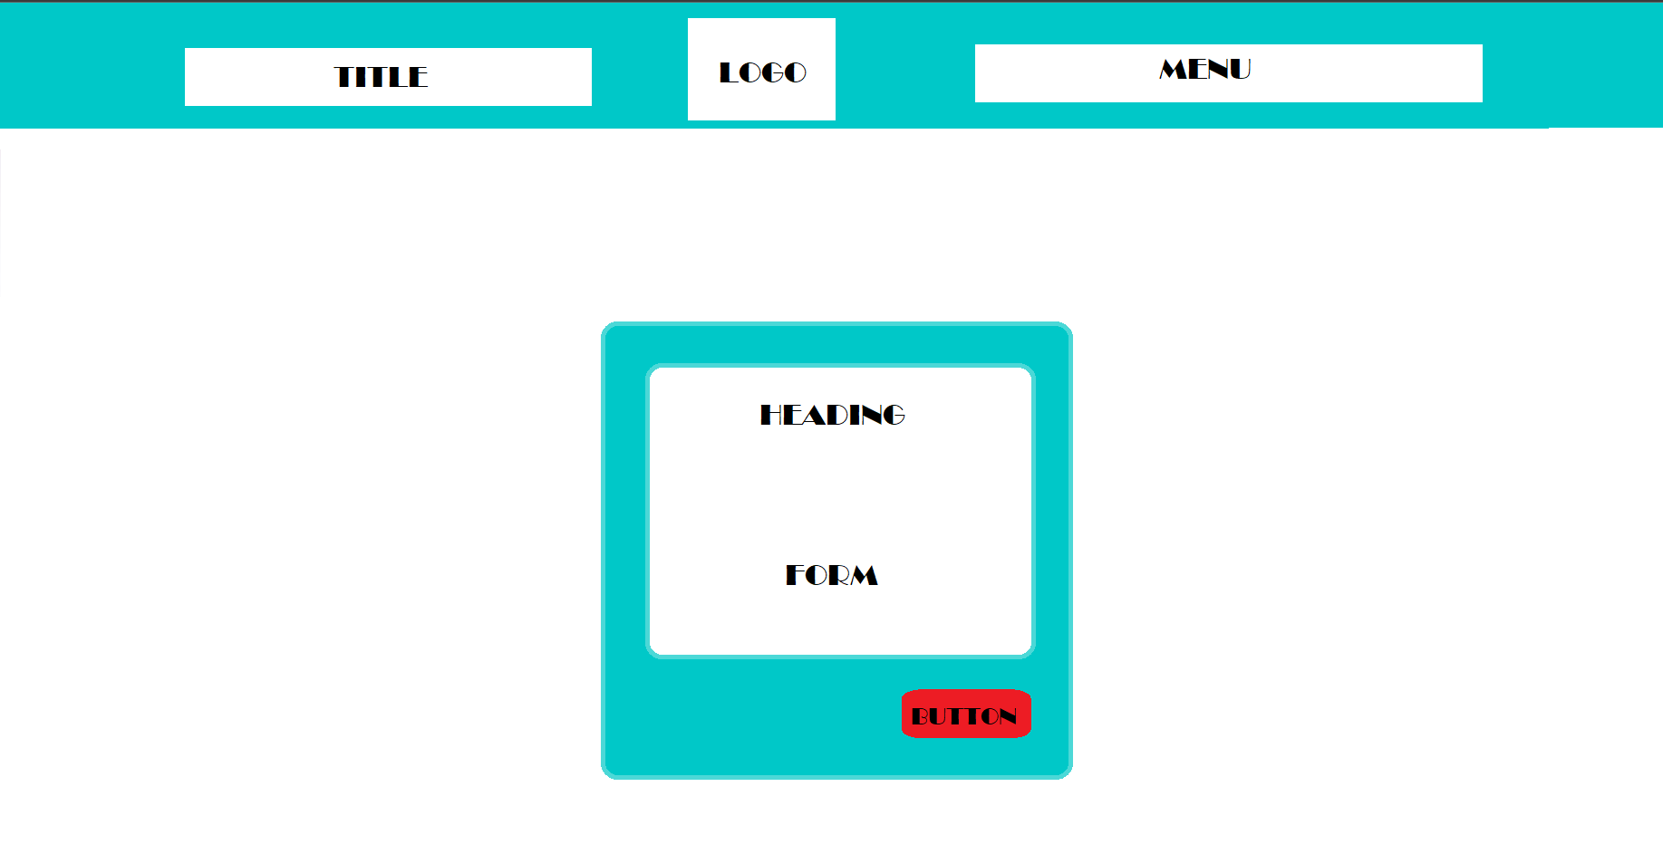

4.Screenshots

Home Page

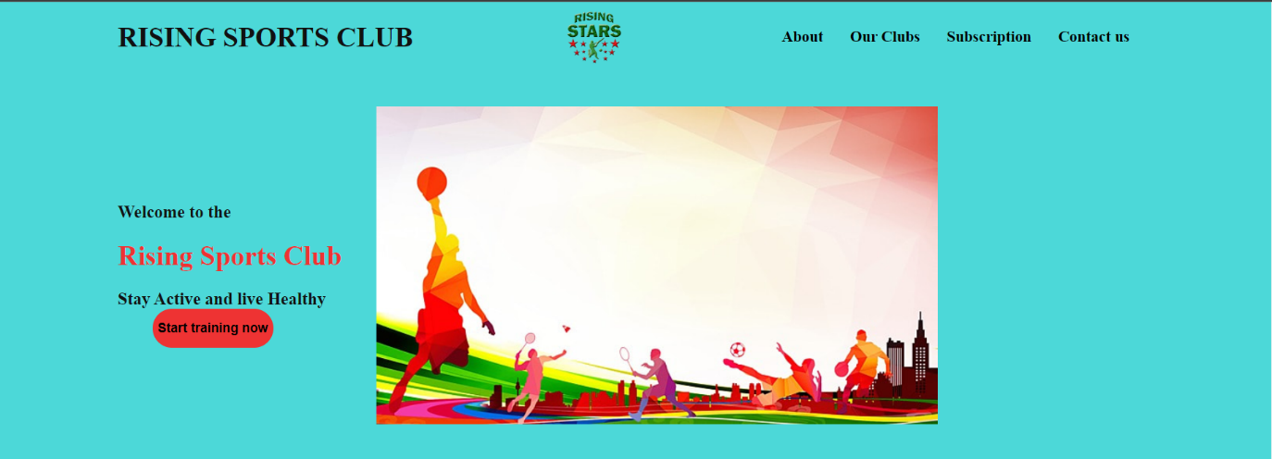

About Us

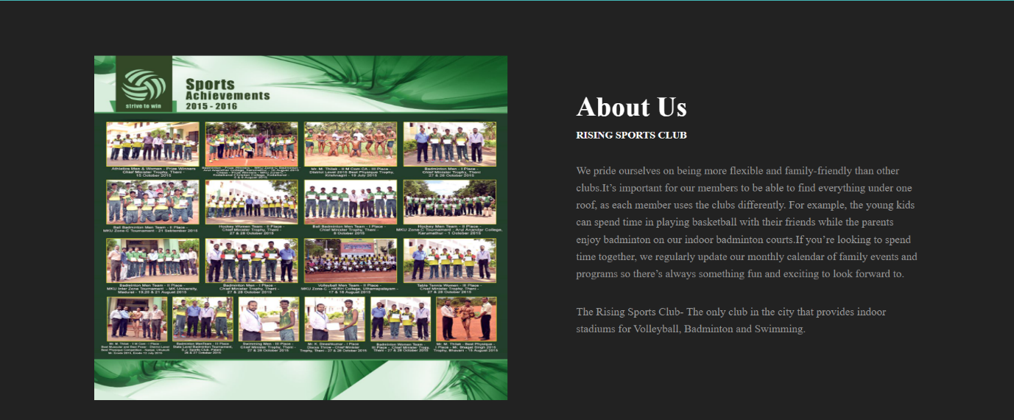

Our clubs

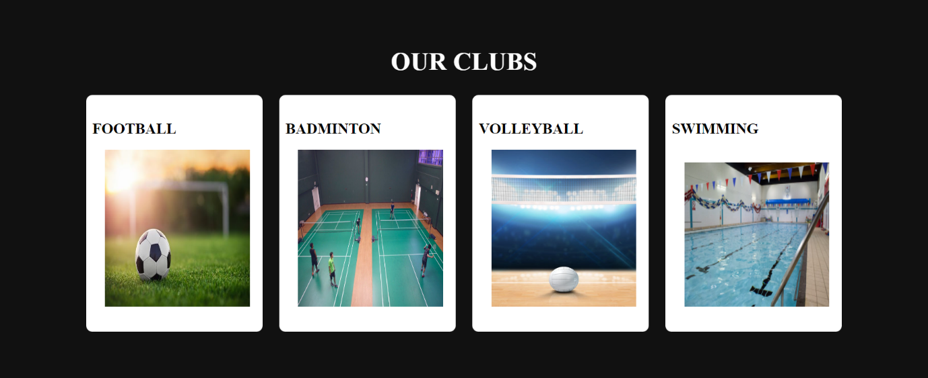

Subscriptions

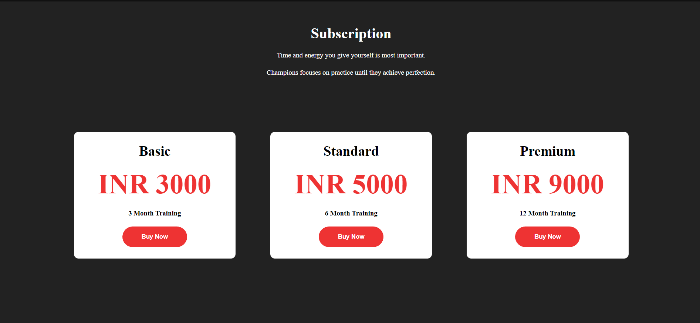

Contact us



Subscription page

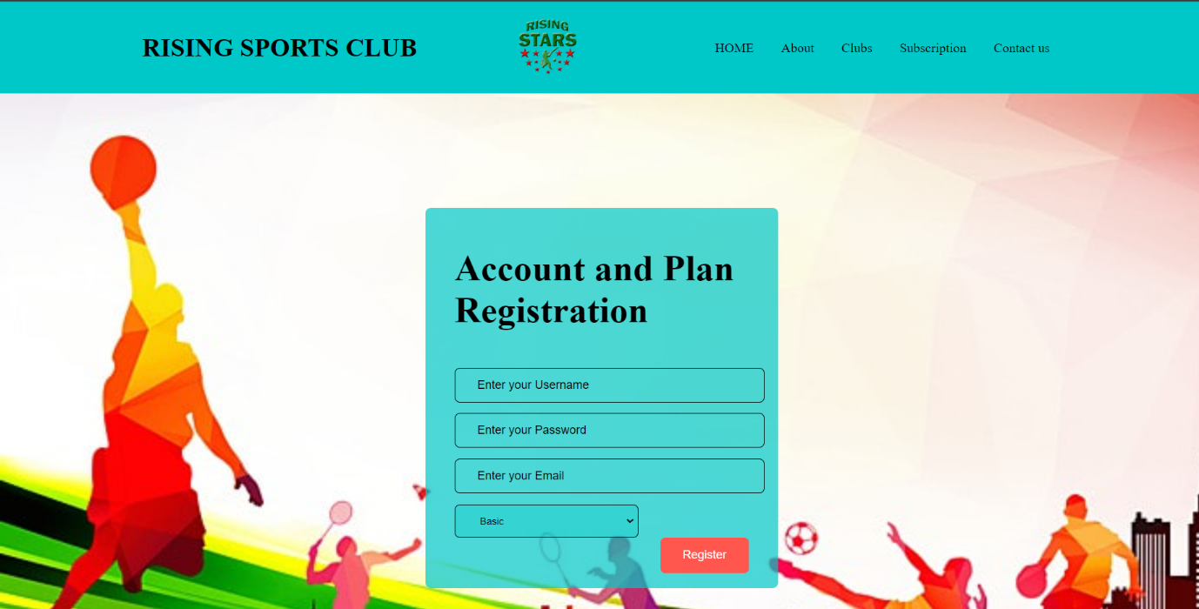

5.Future work

* Adding a user profile with password will improve the overall security of the system.
* Adding a map function to show the location of the clubs
* Adding a search bar to locate the required area
* Adding an event area to show the club event available and as well as future events
* Adding an area to show the number of current club members
* Adding an area where a live countdown occurs for an upcoming event